**Assignment No. 1**

* **Select Clause with Where clause**

1. Display details of jobs where the minimum salary is greater than 10000.

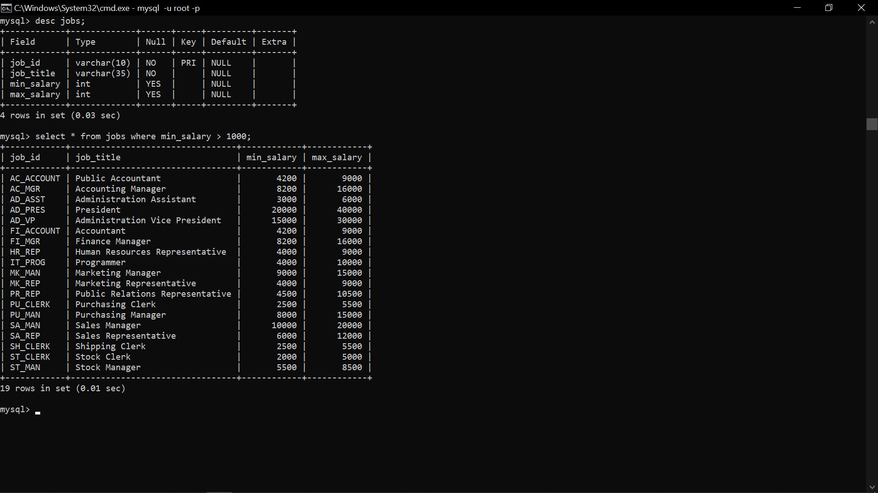

2) Display the first name and join date of the employees who joined between 2002 and 2005.



3) Display first name and join date of the employees who is either IT Programmer or Sales Man.

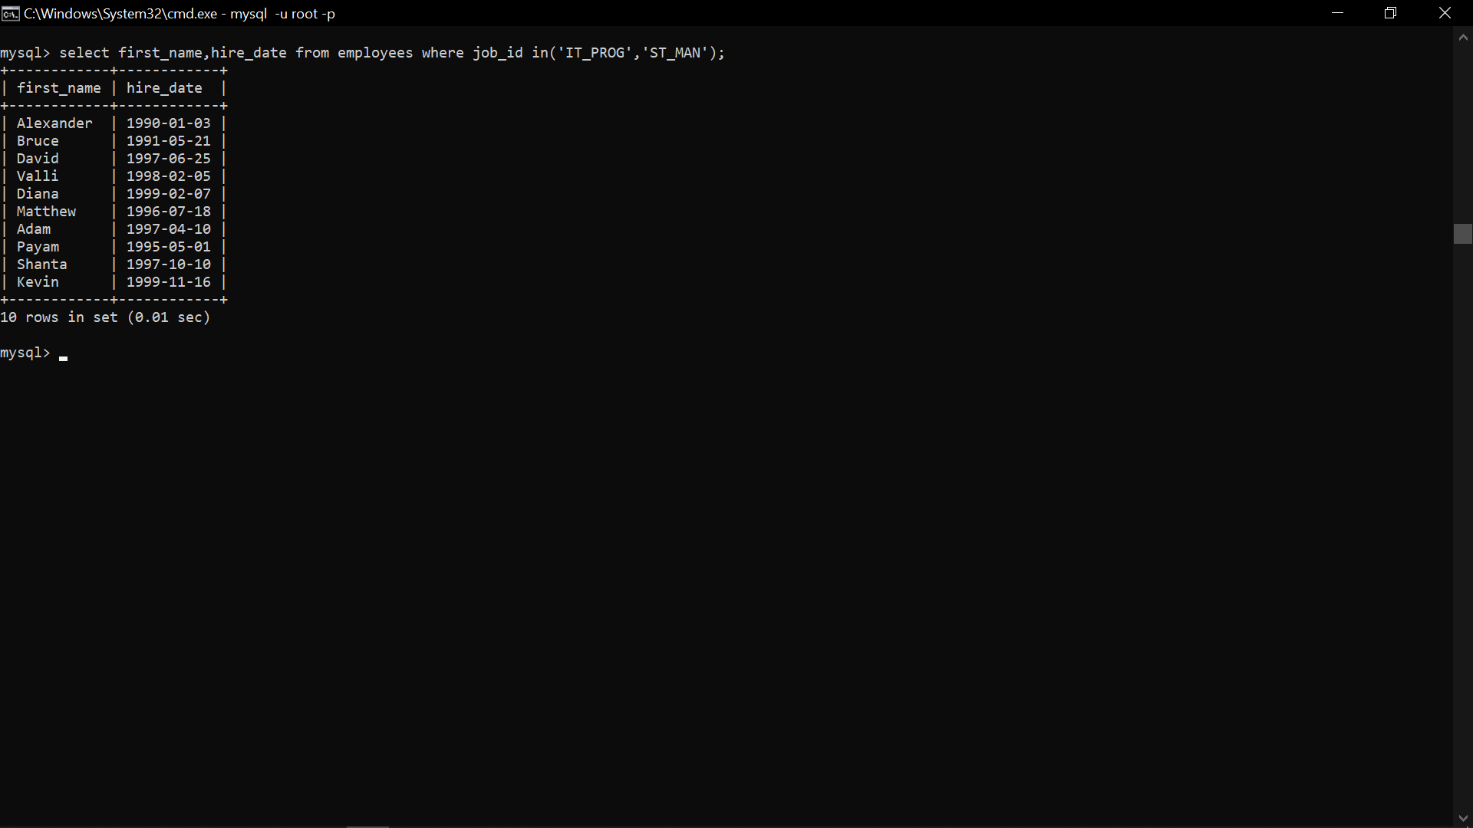

4) Display first name, salary, commission pct, and hire date for employees with salary less than 10000.

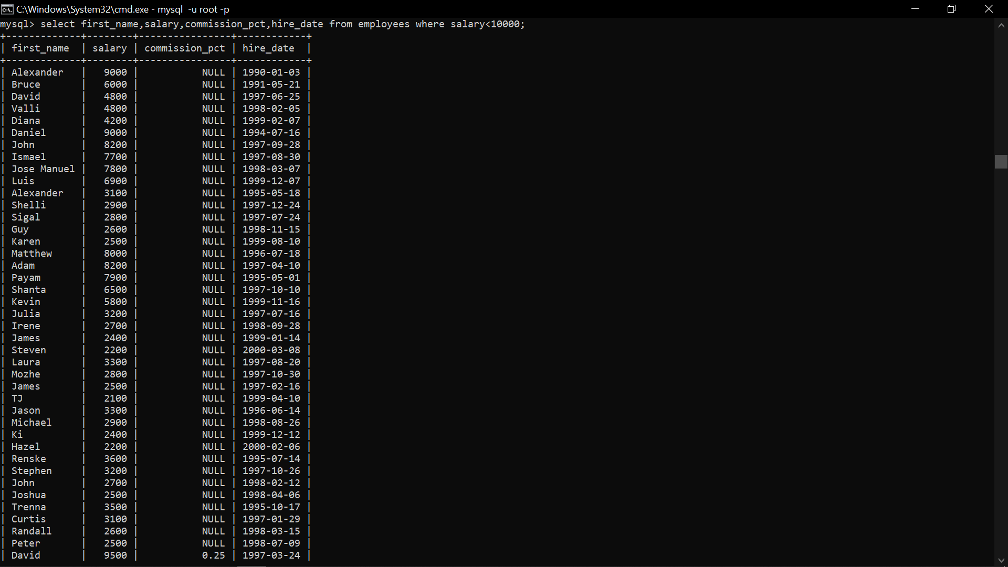





5) Display job Title, the difference between minimum and maximum salaries for jobs with max salary in the range 10000 to 20000.

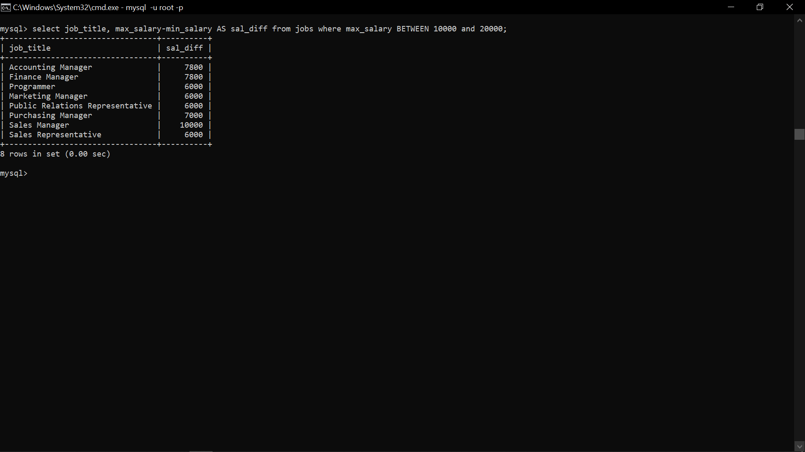

6) Display employees where the first name or last name starts with S.

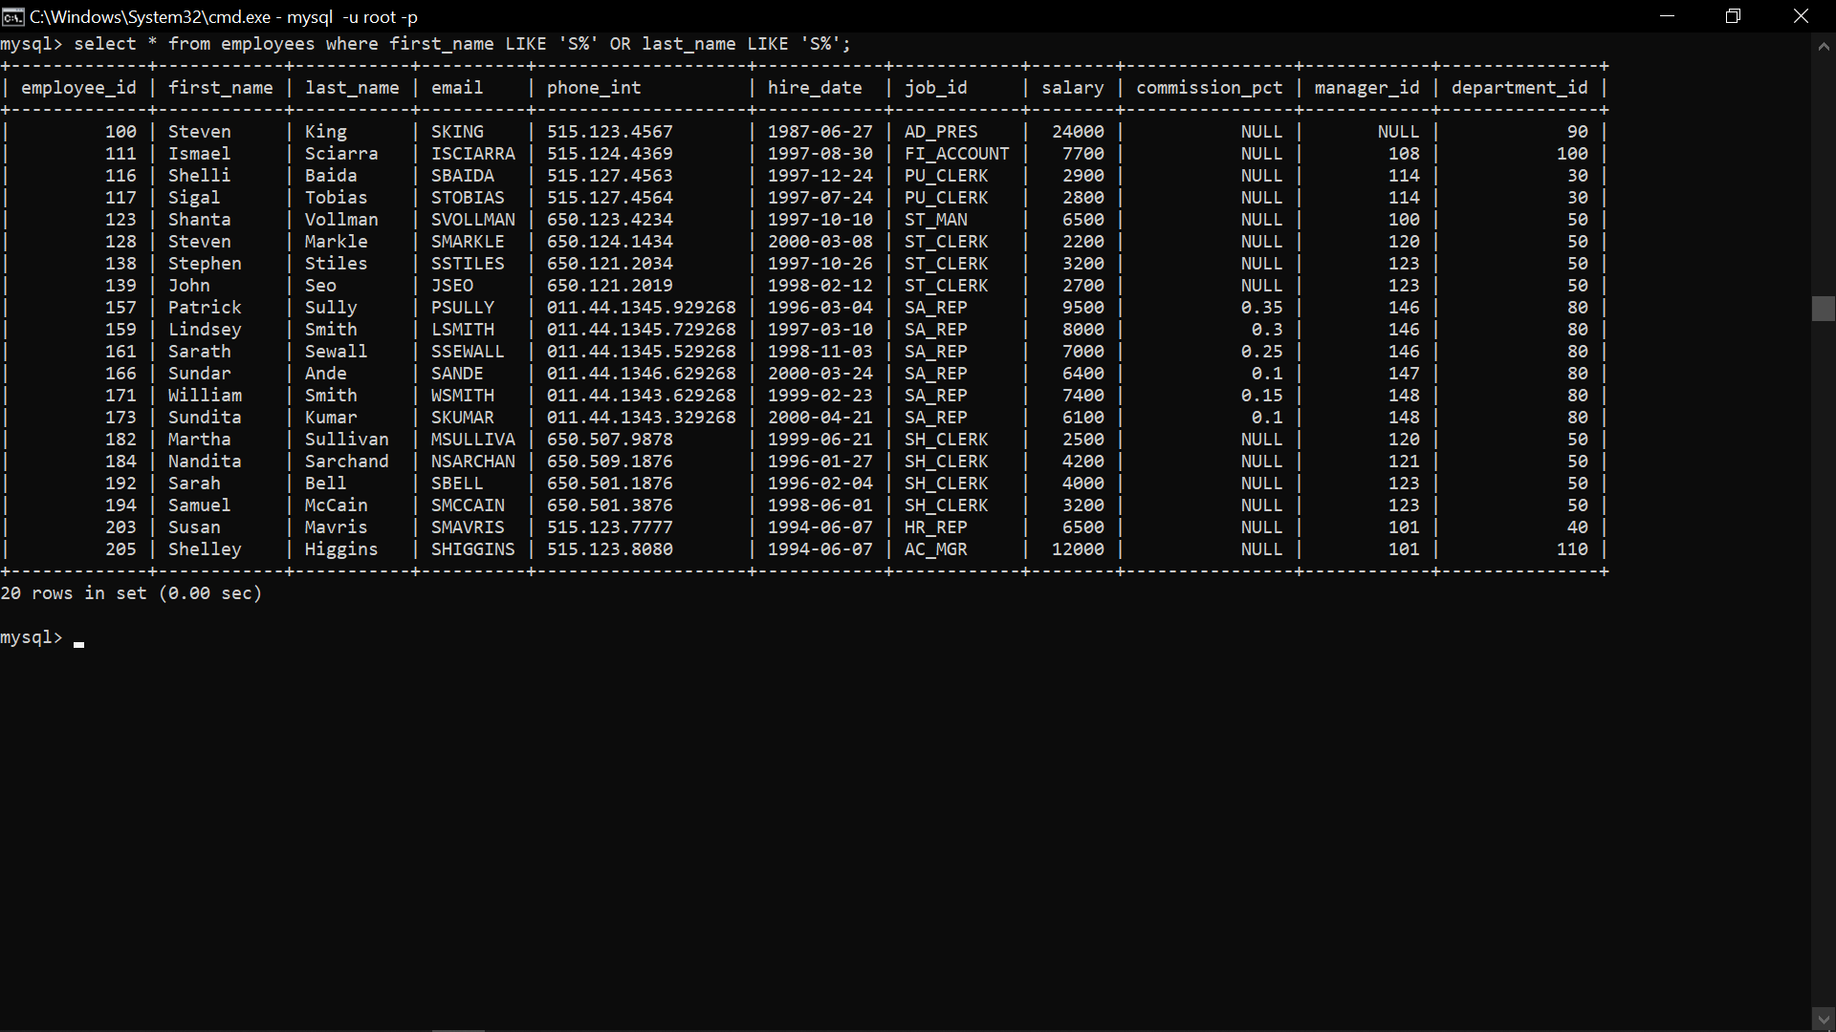

7) Display details of jobs in the descending order of the title.

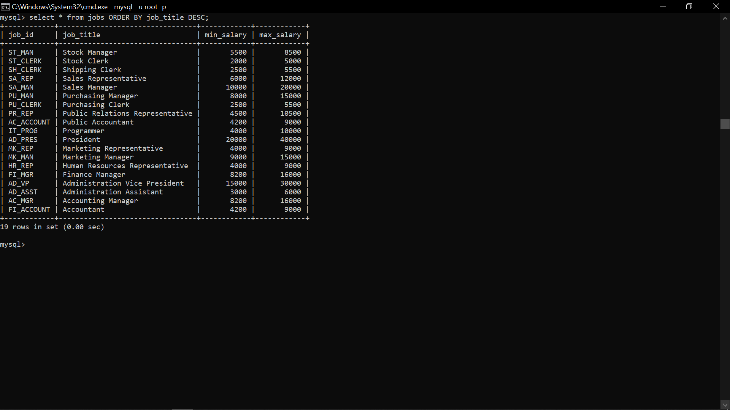

8) Display employees who joined in the month of May.

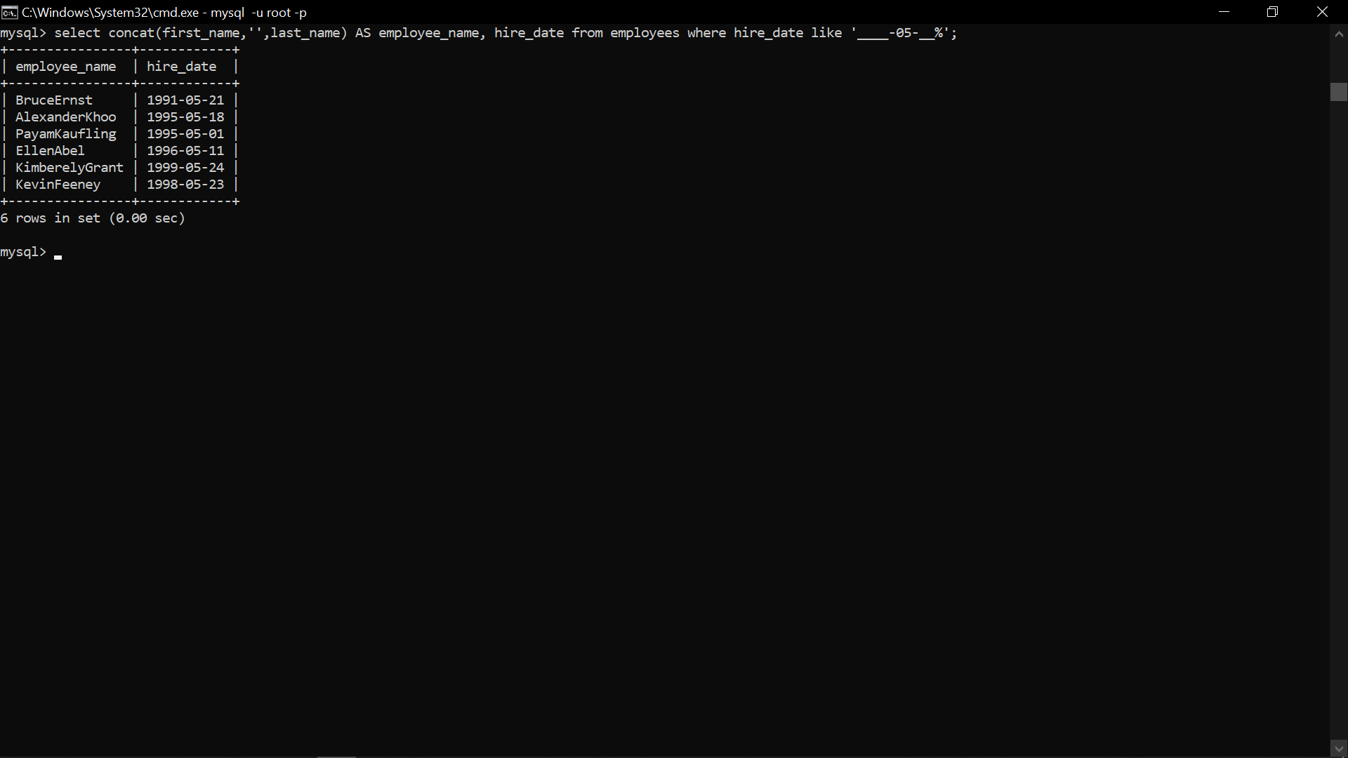

9) Display details of the employees where commission percentage is null and salary in the range 5000 to 10000 and department is 30.

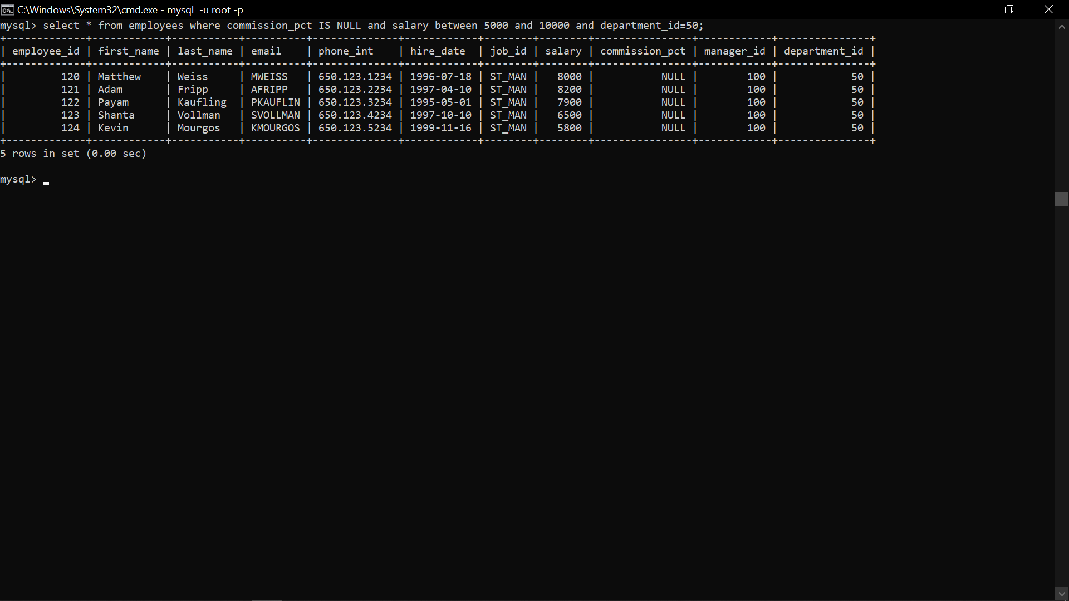

* **Join**

1)Display job title, employee ID, number of days between ending date and starting date for all jobs in department 30 from job history.

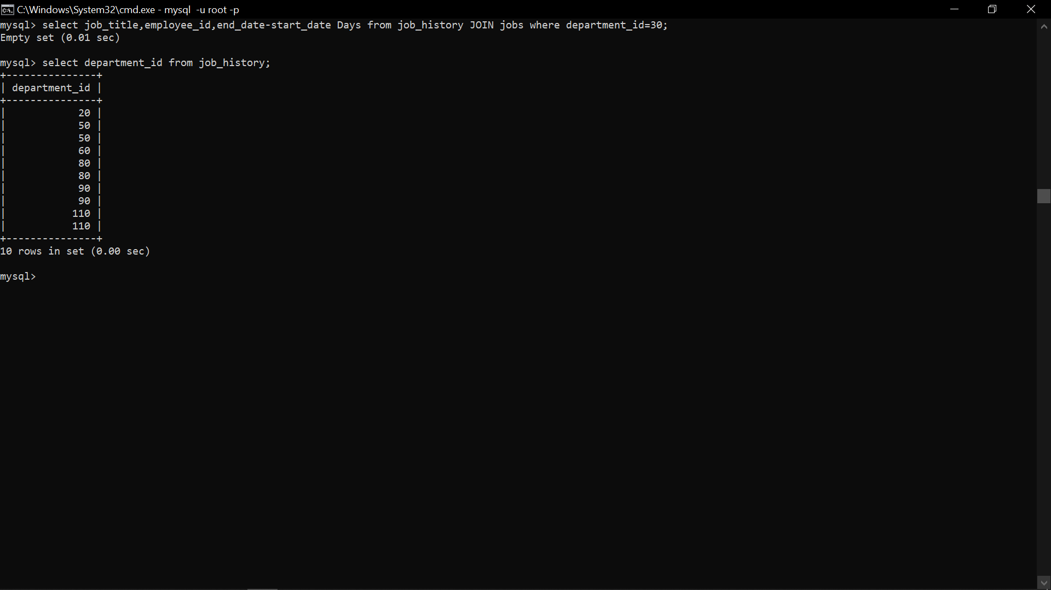

2) Display department name and manager first name.

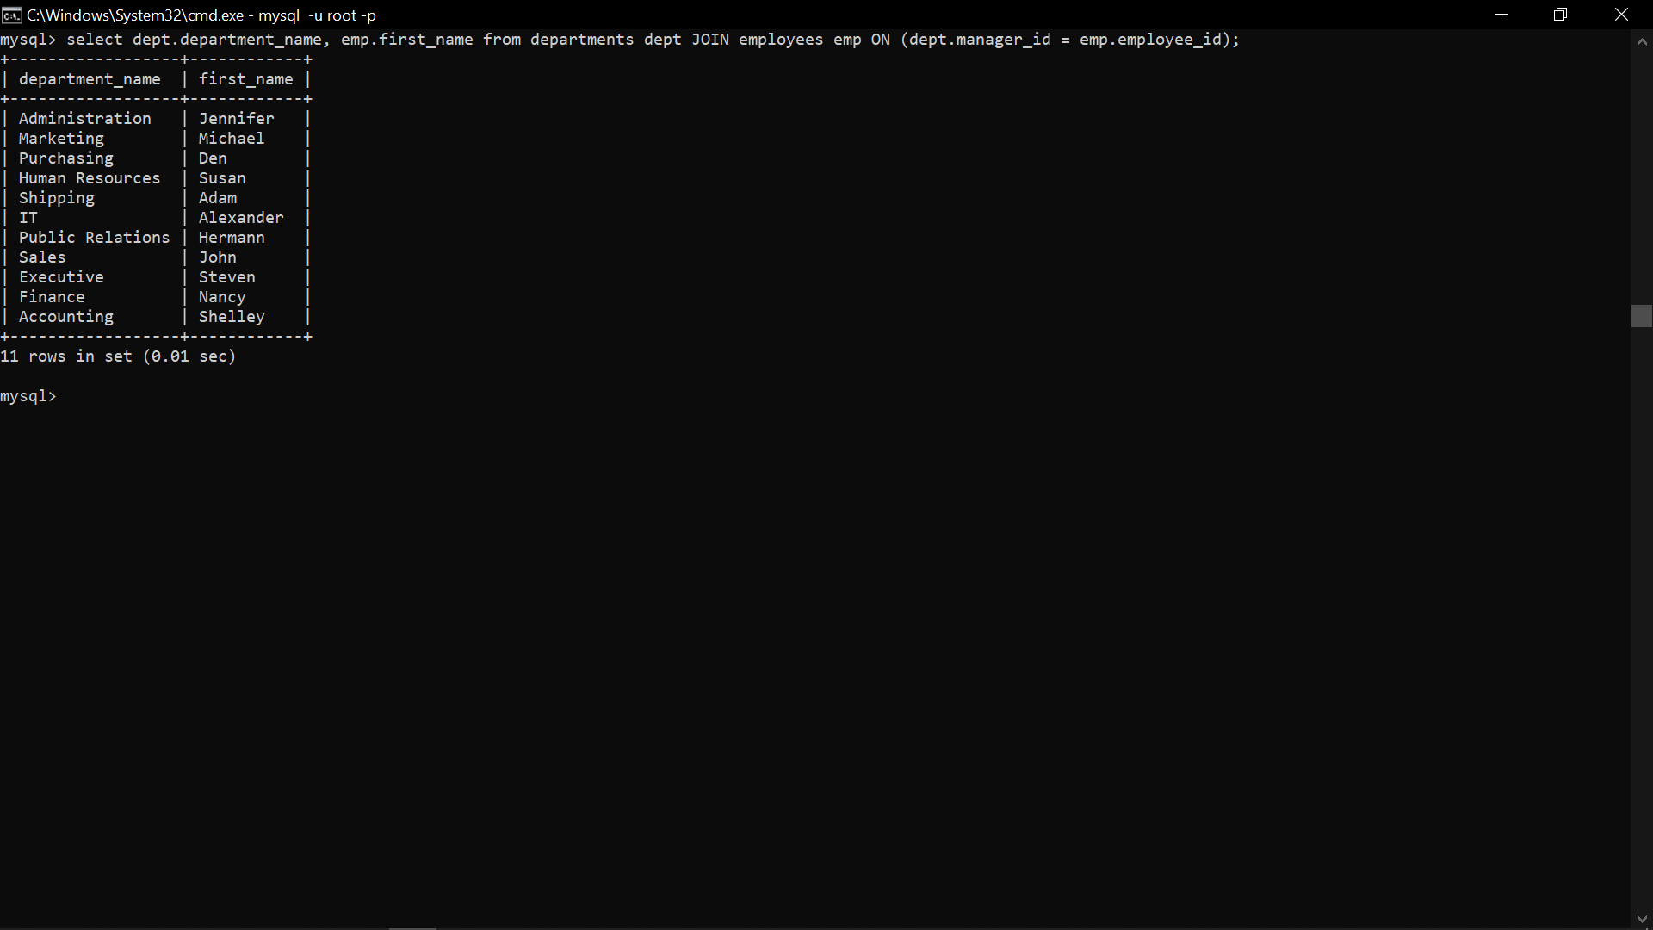

3) Display department name, manager name, and city.

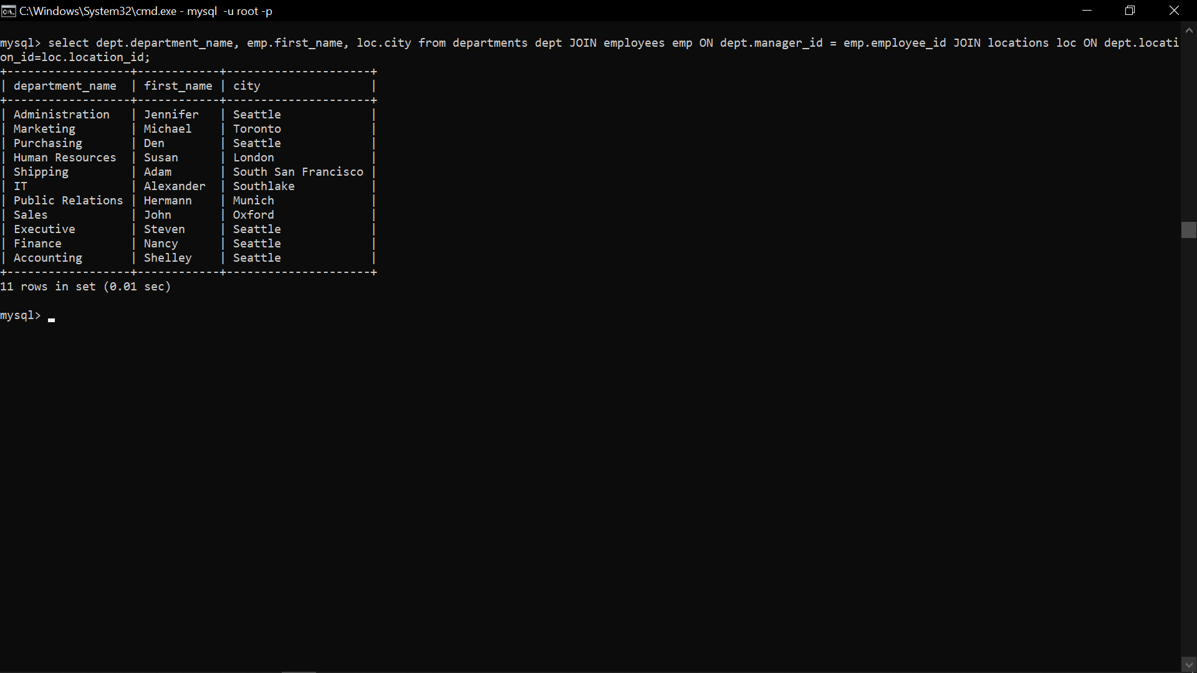

4) Display country name, city, and department name.

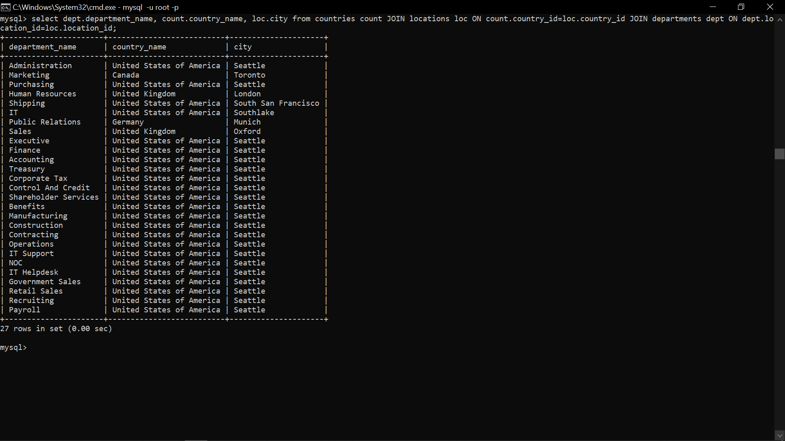

5) Display employee name and country in which he is working.

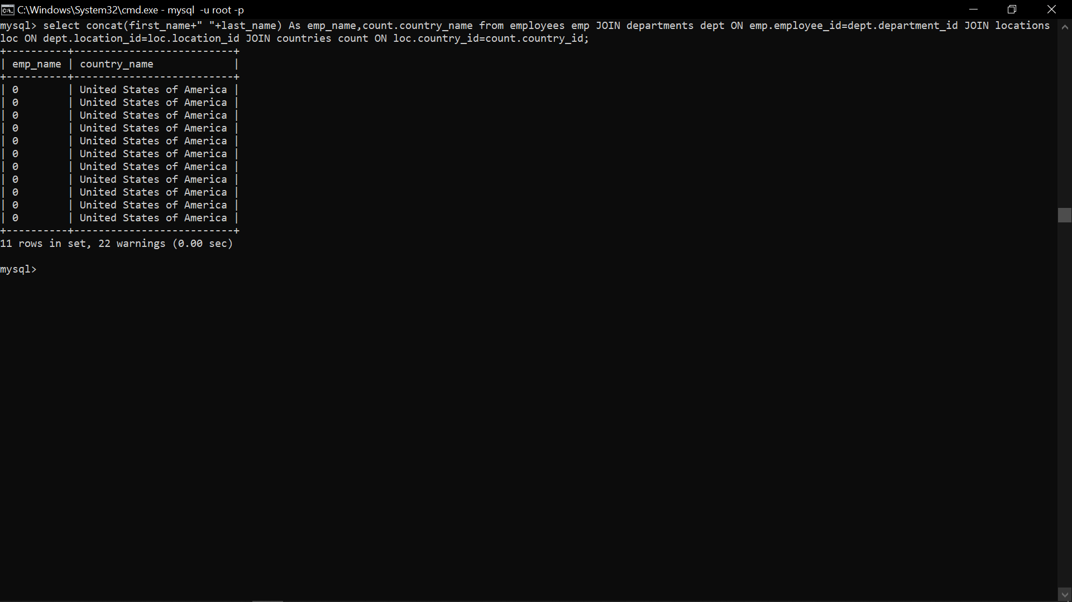

* Functions

1. Display employees who joined in the month of May.

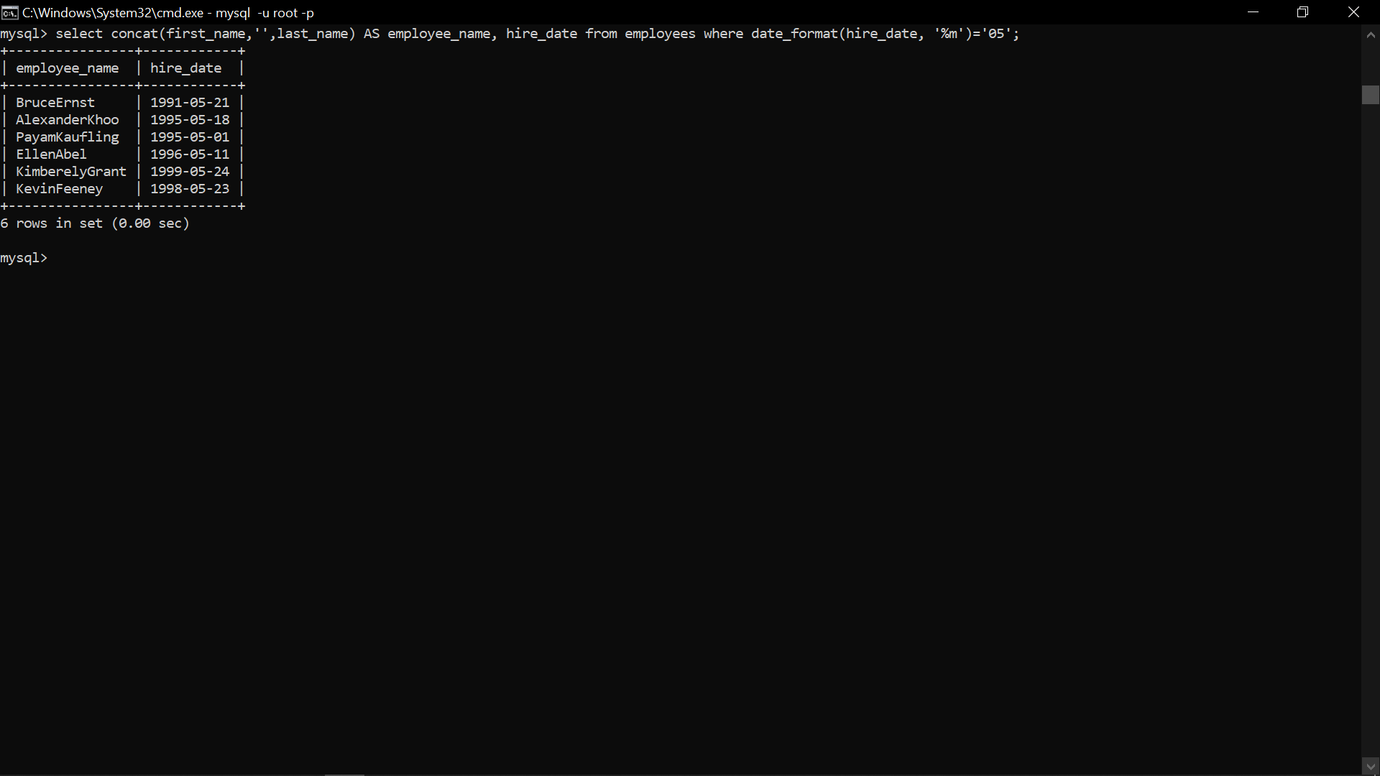

2. Display first name, salary, and round the salary to thousands.

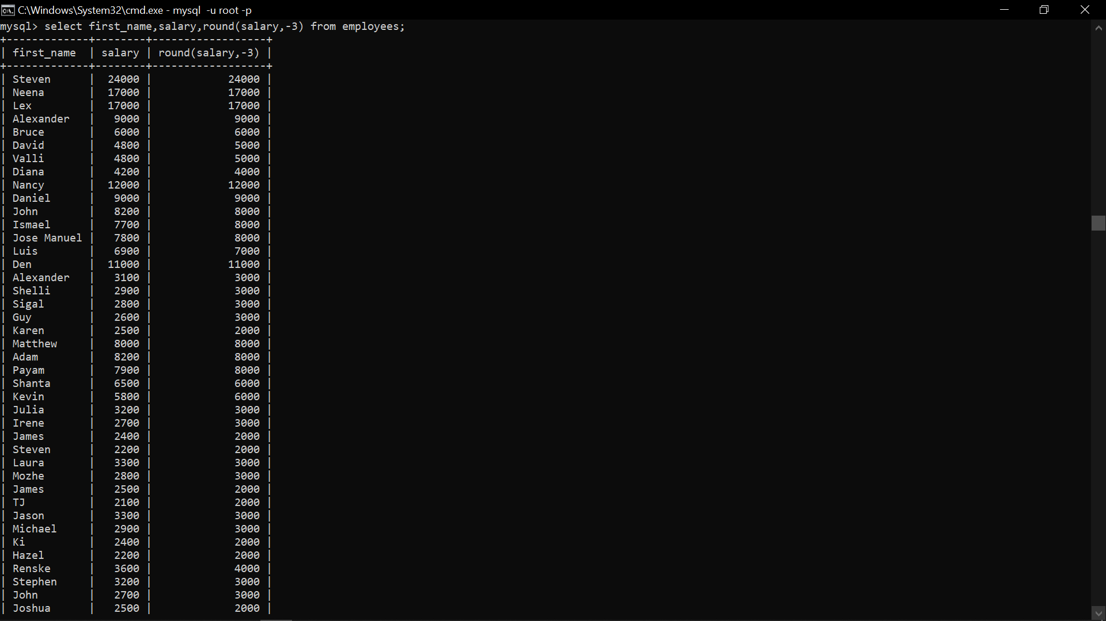



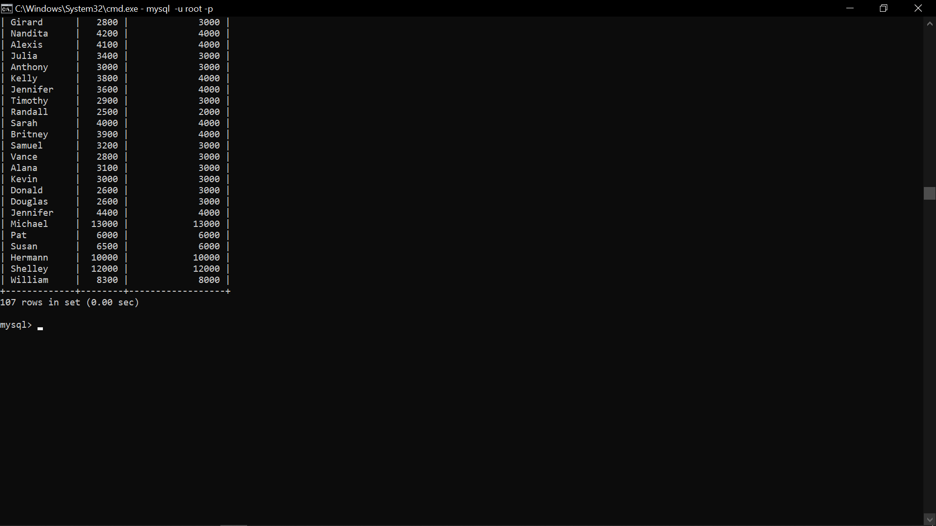

3. Display first name and date of first salary of the employees.

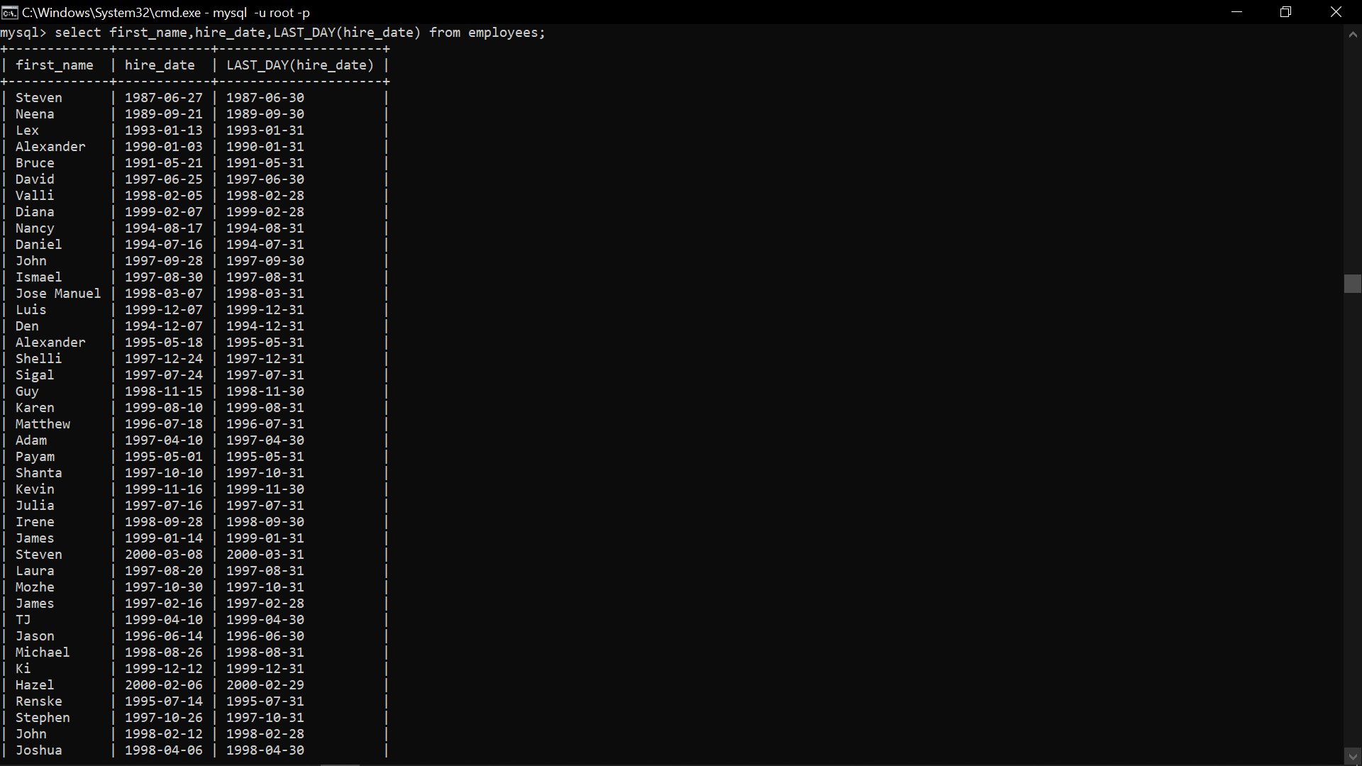





4. Display first name and experience of the employees.

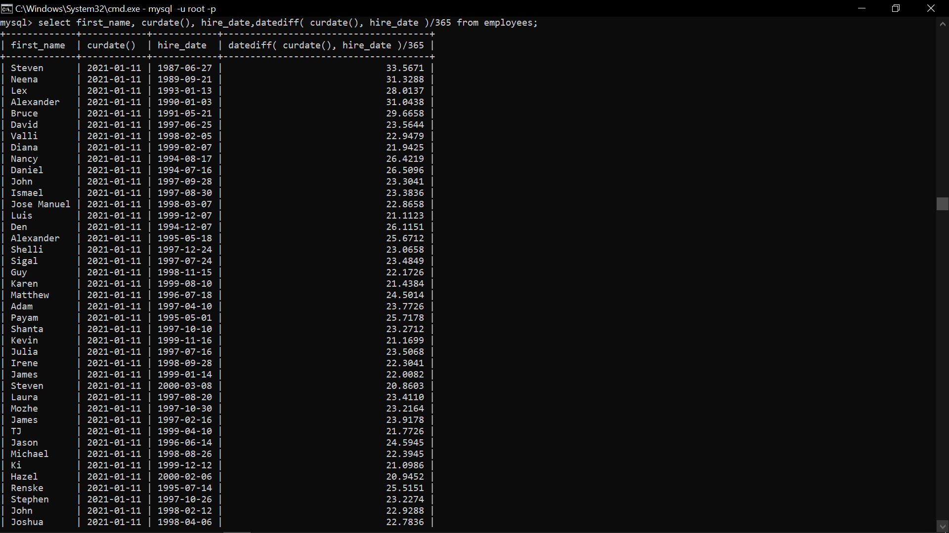



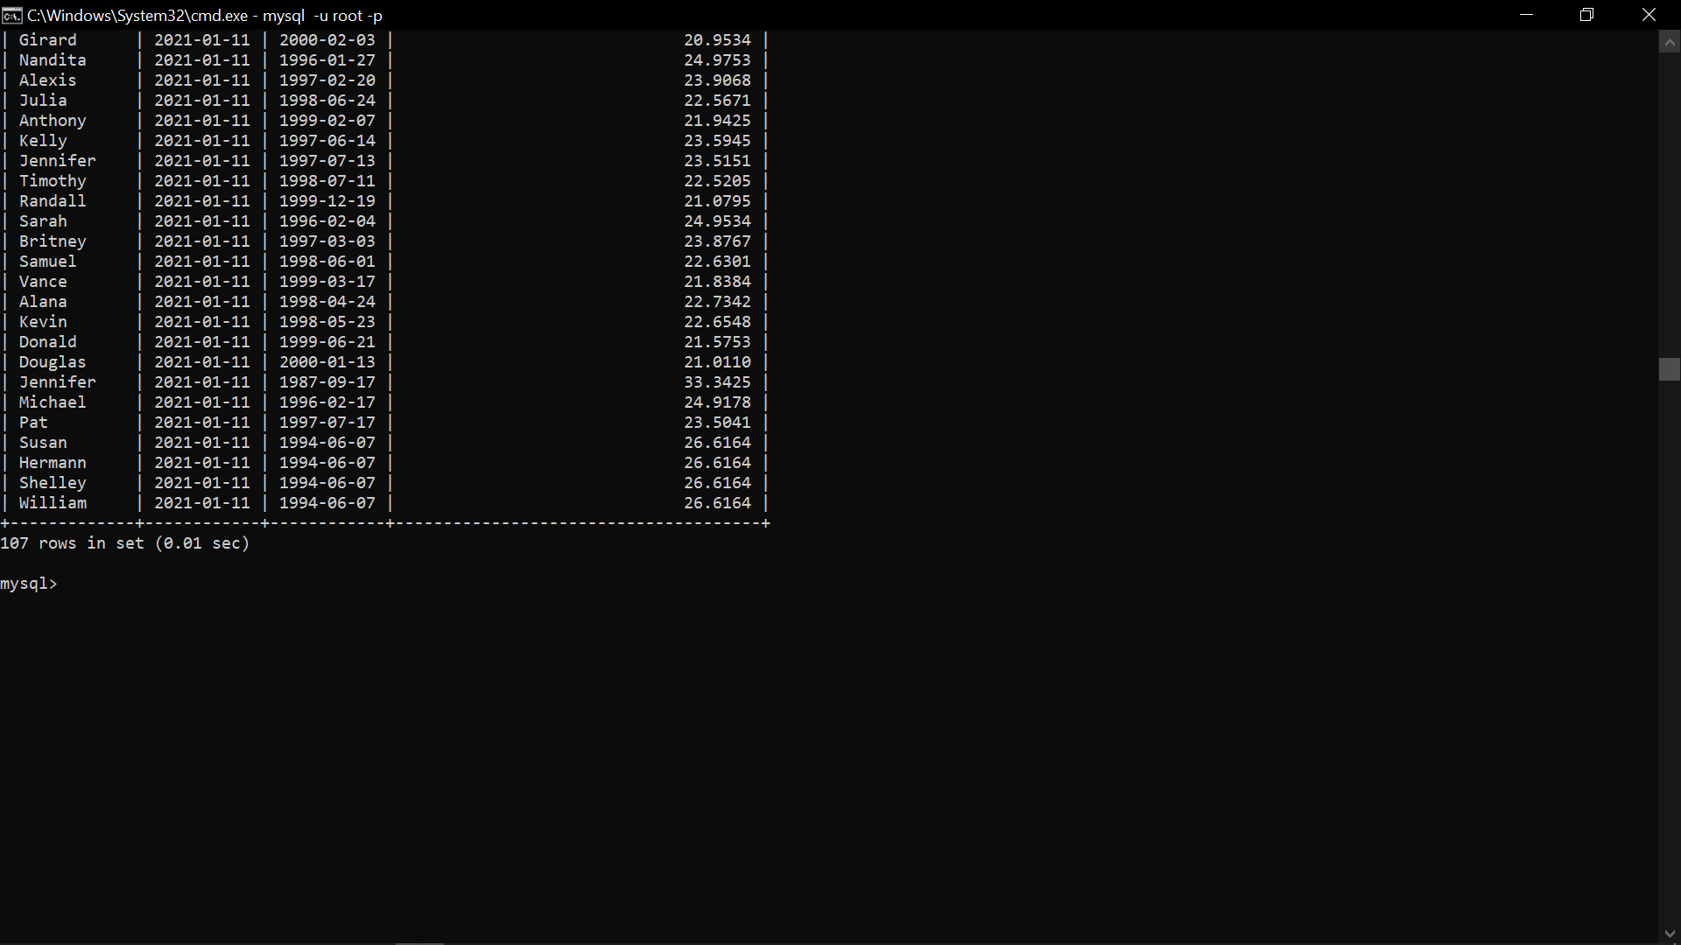

5. Display the length of first name for employees where last name contain character ‘b’ after 3rd position.

6. Display first name in upper case and email address in lower case for employees where the first name and email address are same irrespective of the case.

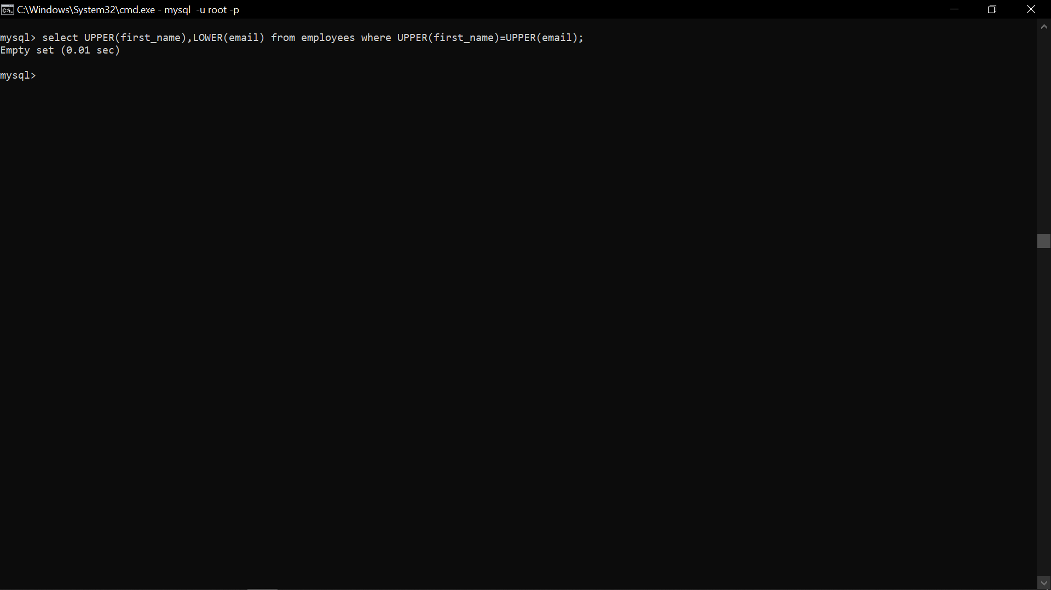

7. Display employees who joined in the current year.



8. Display the number of days between system date and 1st January 1995.



9. Display how many employees joined in each month of the current year.

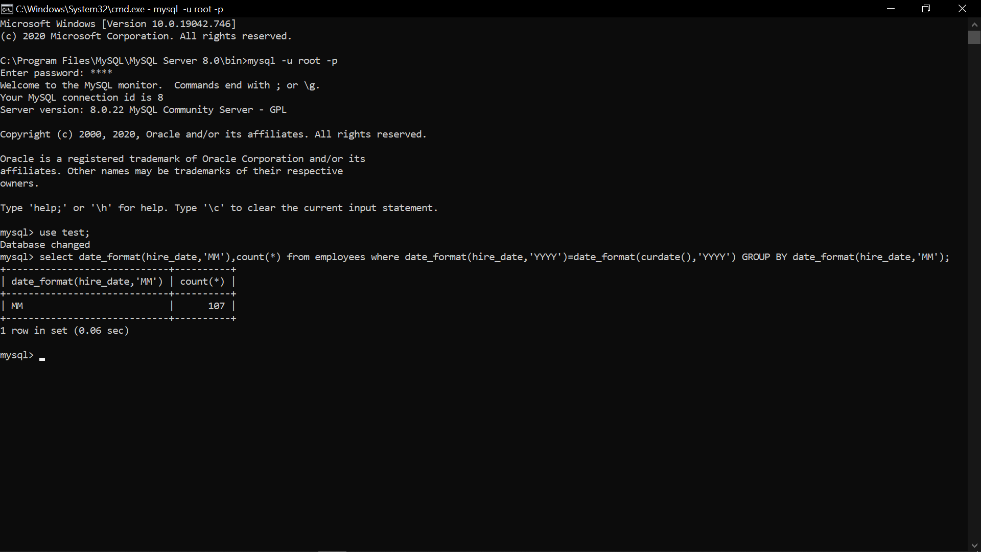

* **MySQL Aggregate function**

1. Display employee ID and the date on which he ended his previous job.

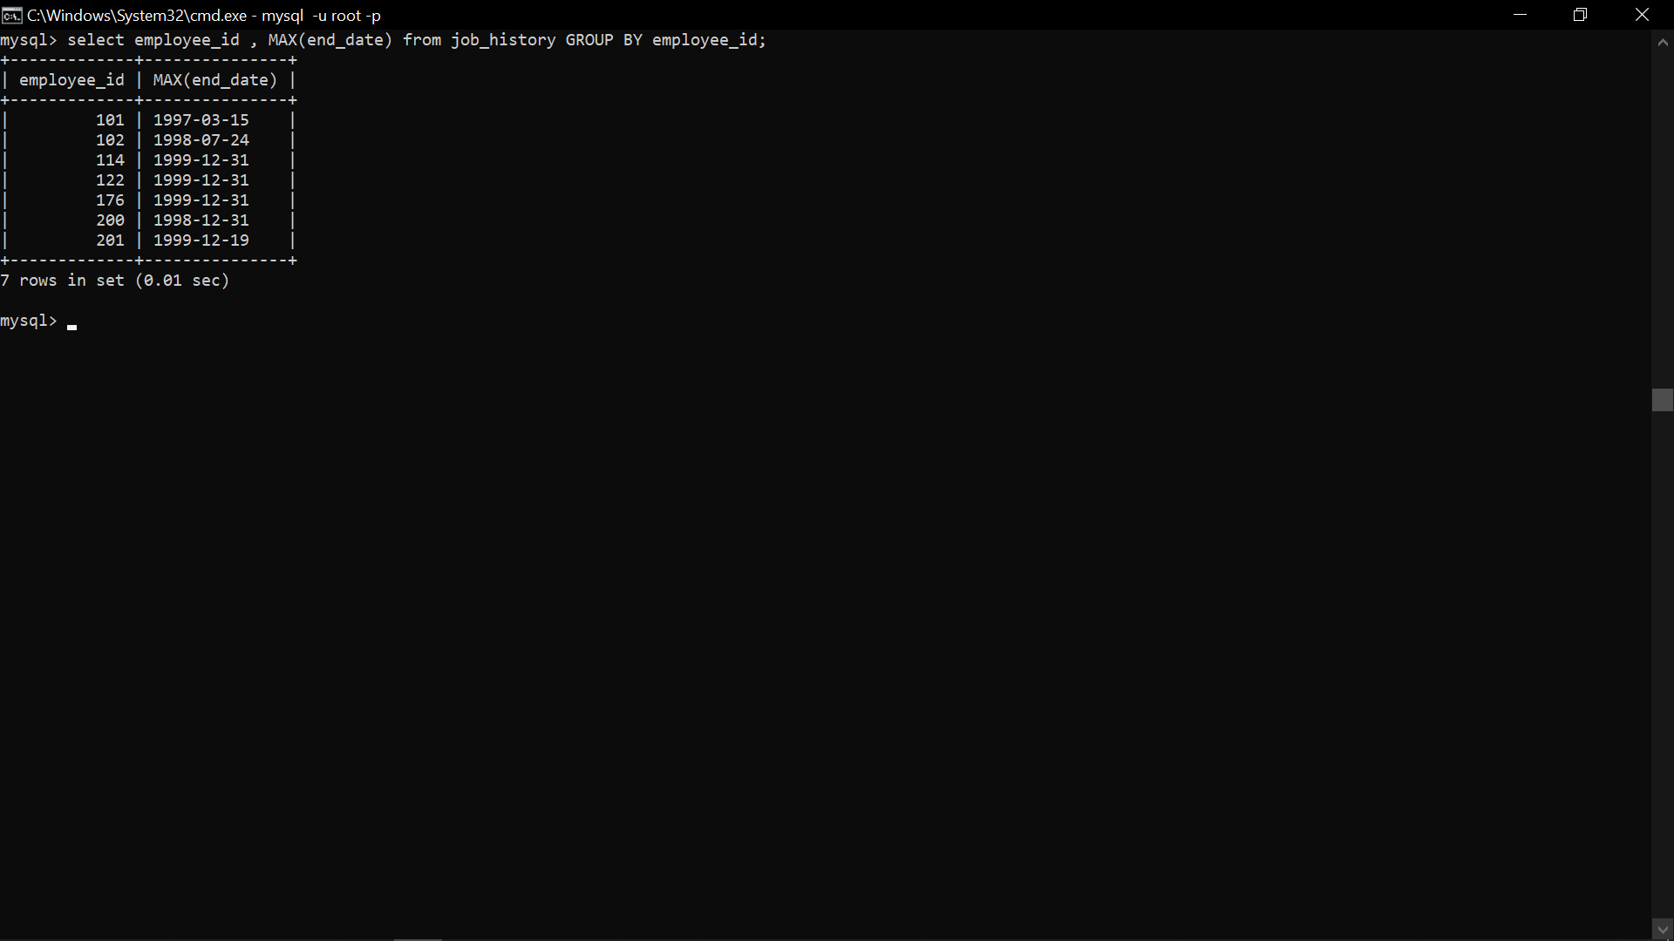

1. **Display number of employees joined after 15th of the month.**



* **Select with Group by**

1. Display the country ID and number of cities we have in the country.



1. Display average salary of employees in each department who have commission percentage.

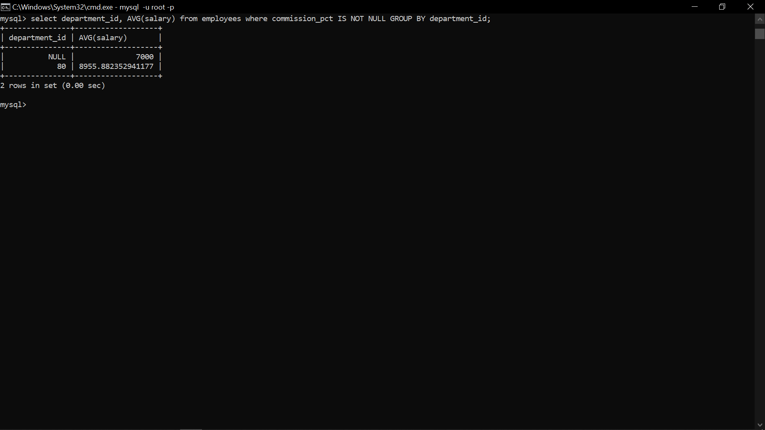

3. Display job ID, number of employees, sum of salary, and difference between highest salary and lowest salary of the employees of the job.

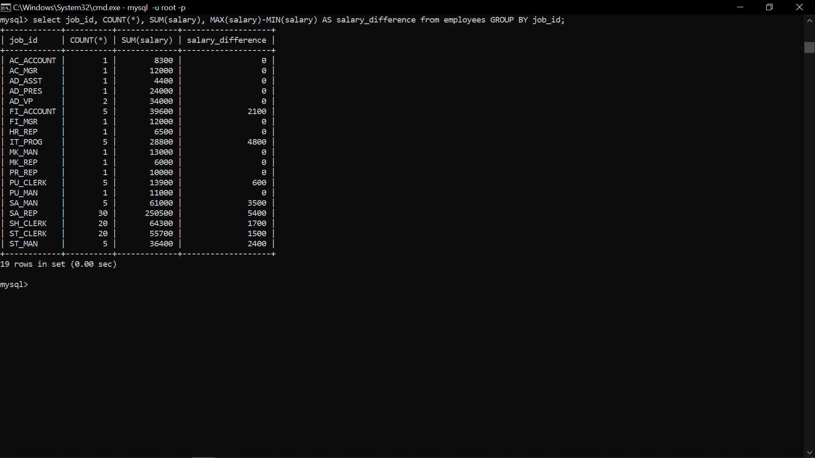

4.Display job ID for jobs with average salary more than 10000.

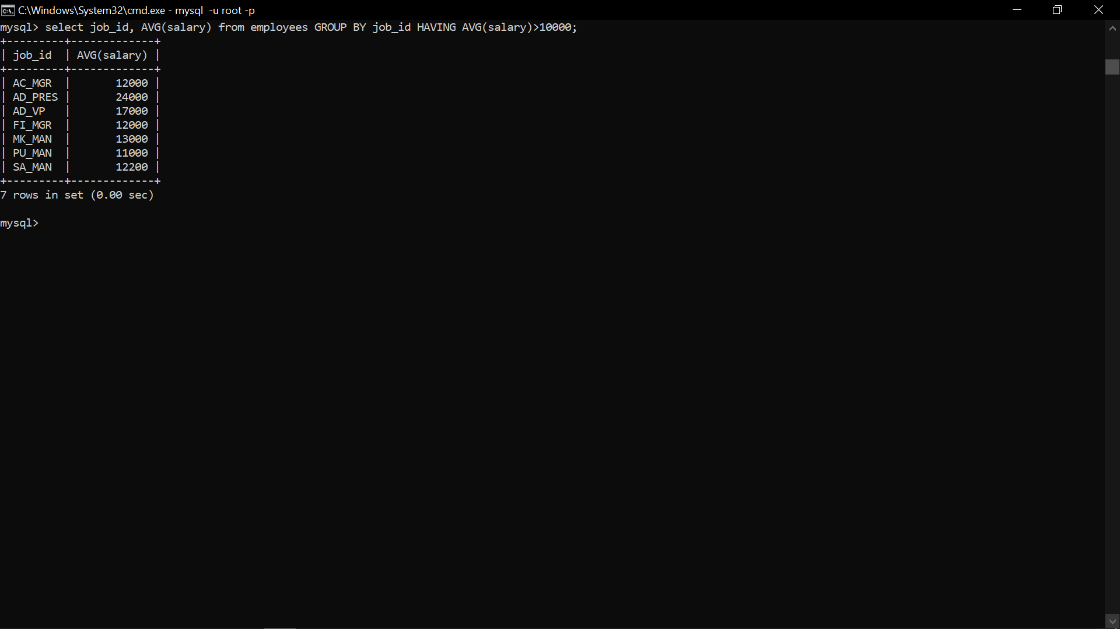

5.Display years in which more than 10 employees joined.

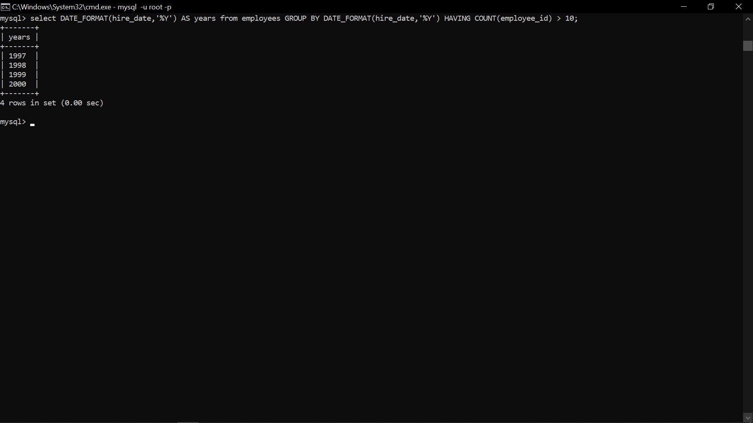

6.Display departments in which more than five employees have commission percentage.



7.Display department name and number of employees in the department.

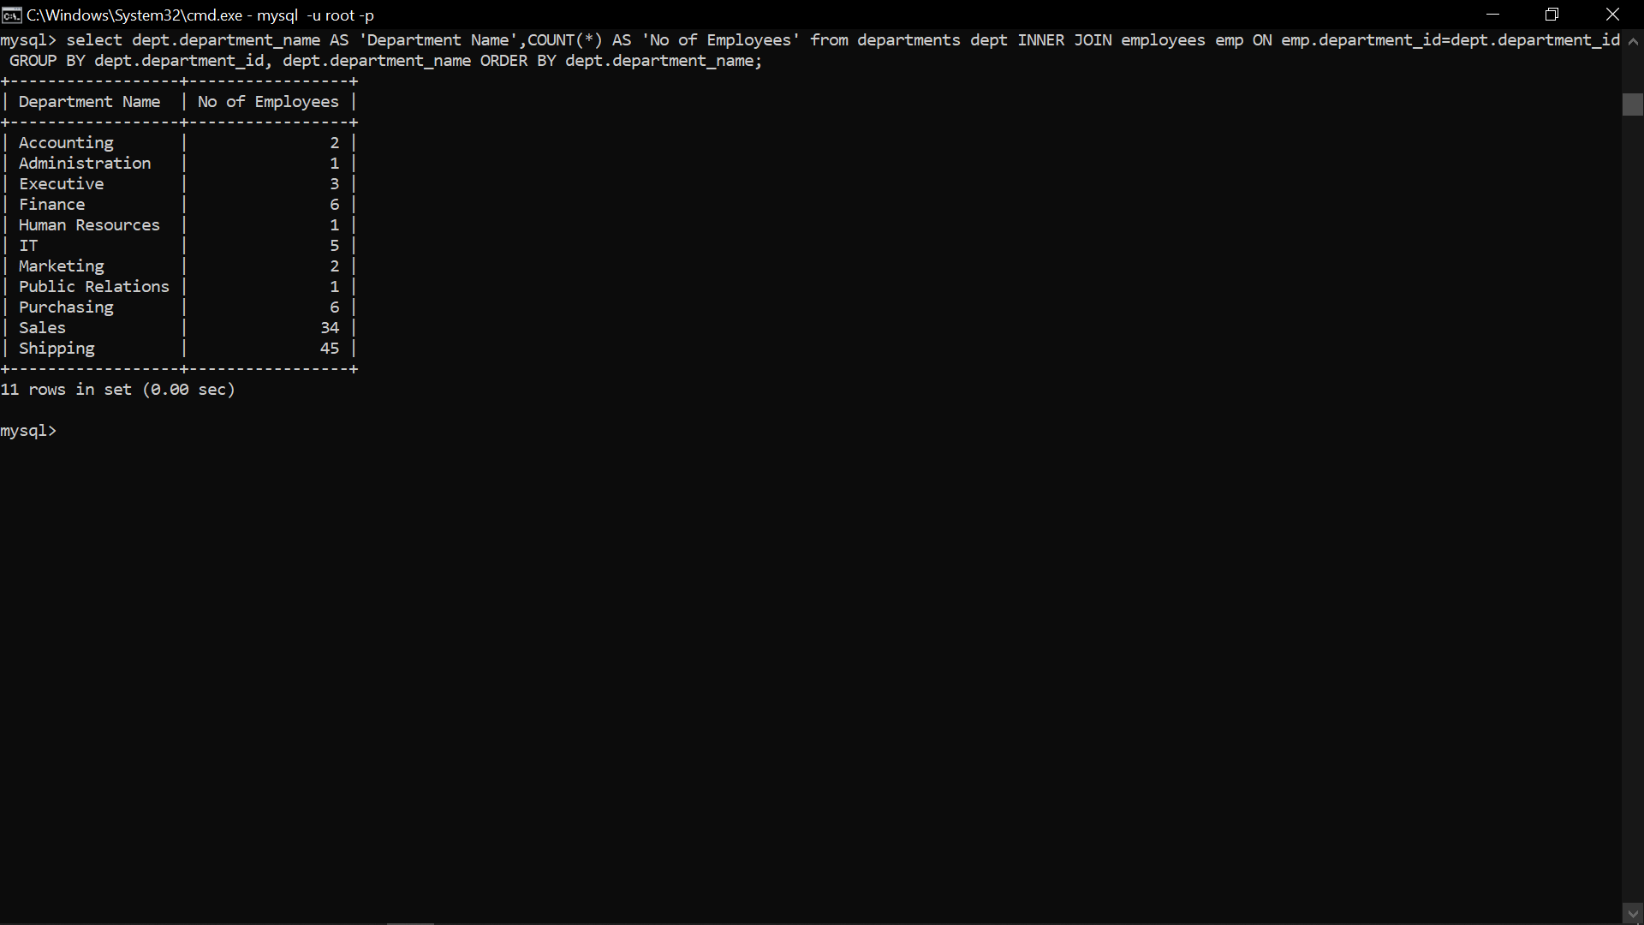

8.Display employee ID for employees who did more than one job in the past.

